Swagger API Screenshot

Appointment API URL

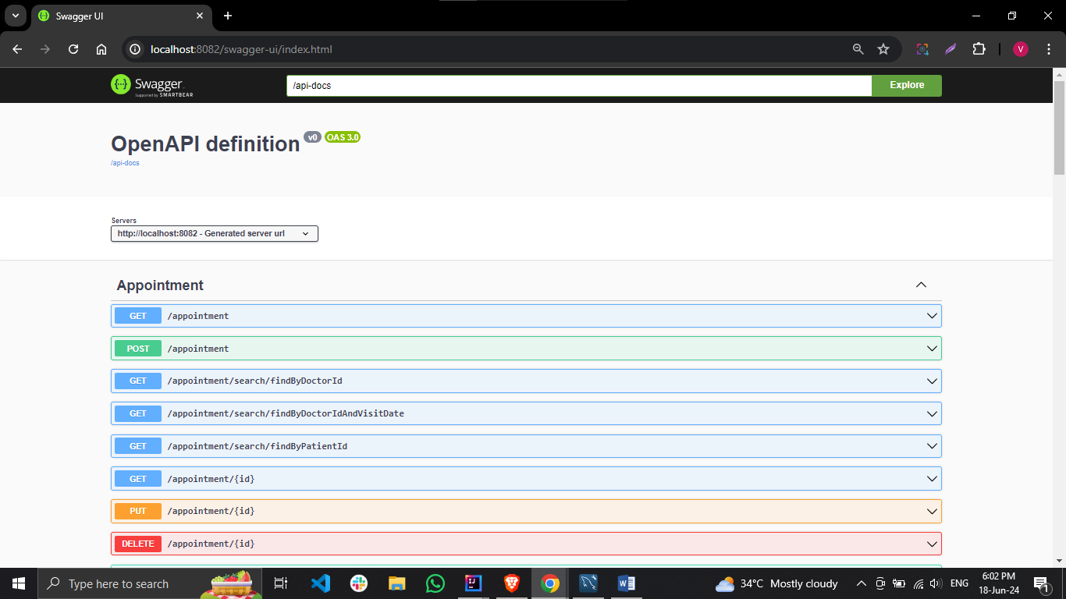

Doctor API URL

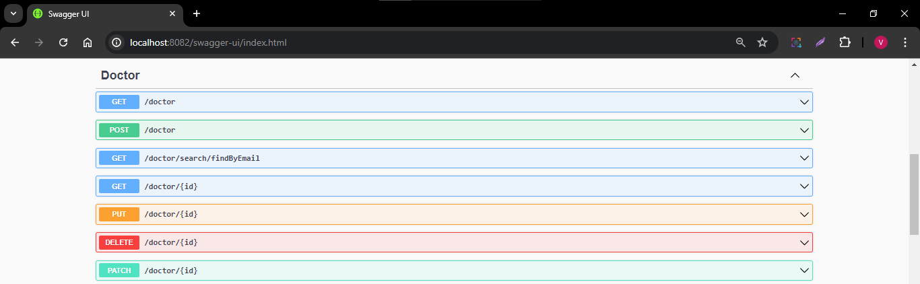

Patient API URL

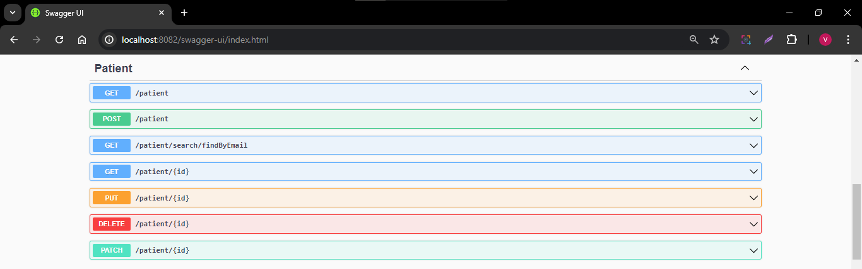

Prescription API URL

